Executive Director Report

Pic

The Semi-Annual Meeting of the MEUA will be held at the Embassy Suites— Destiny USA location, April 22-23, 2020. Registration forms and meeting materials will be sent out so the members can get enrolled.

This year, we will again offer more meeting time so that ample time is given to the attendees to be brought up to date on the public power matters especially here in New York State.

Please plan on attending.

The Engineering Workshop scheduled for March 18-19 again has great participation and an interesting and educational agenda. If you haven’t already signed up, please consider doing so.

This week I did some lobbying with John Jennings at the State level. We had the opportunity to meet with several officials and discussed energy & budget issues. It was such a surprise to see the number of protesters who assembled at what seemed like every floor of the legislative office building. A contingent from the nursing sector is pushing for more vaccinations to combat current viruses and disease in schools and nationwide.

The Assembly & Senate budgets are not out yet, but should be by the middle of March…a little later than usual. It will be interesting to see how they may differ from the Governor’s proposed package.

The New York Power Authority’s Demand Response Hot Water Heater Program has started some installations in Solvay this week. Penn Yan & Massena are also part of this program. Once all installs of the new heaters are in, we will report on the benefits of the program as it moves forward.

We have received several resolutions from members approving the Long-Term Agreement with NYPA.

If you haven’t already done so, please move forward in getting your resolution in to the MEUA office and back to NYPA as well.

Meter School 102

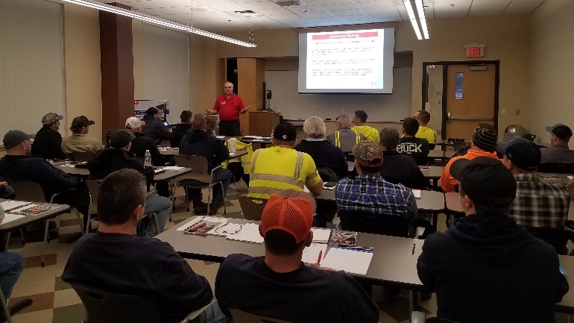

Meter School 102 consisted of two busy days with TESCO doing hands on Meter Testing and a ½ day with Itron doing Meter Programming.

Participating students reported that the program was helpful and informative. New technologies and equipment were introduced to the students, as well as instructional reviews on equipment already in use.

Thank you again to Ryan Trinkl and Matt Hegarty of Fairport for organizing the class—and to TESCO and Itron for providing valuable information to our lineman students.

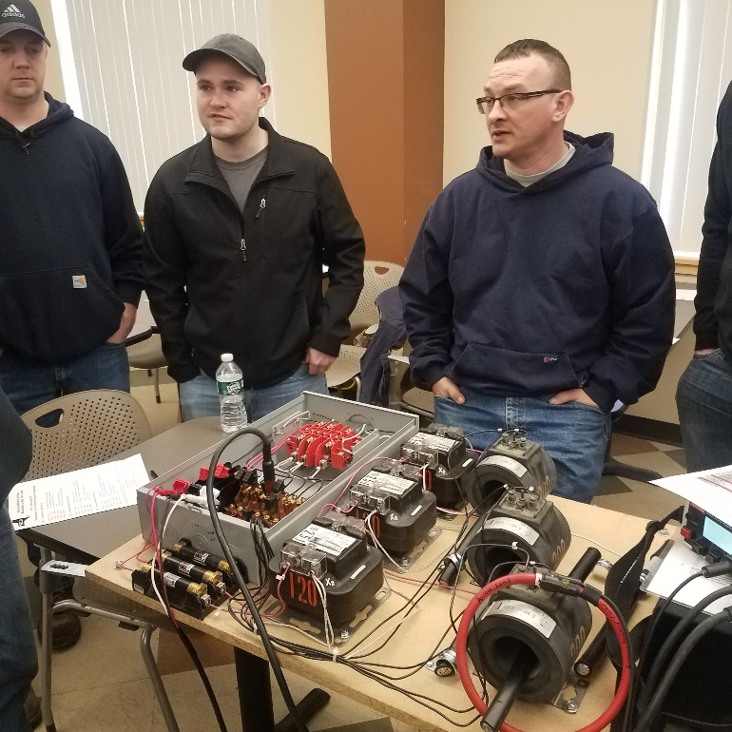

Thanks to the membership for filling the Metering School 102. To those members that inquired after the training session was filled— we will try to schedule another school later in the year.

MEUA Consultant Chris Wentlent

2020 Updates:
March

Executive & Legislative Update
Governor Cuomo conducted his State of State Address on Wednesday, January 8, 2020. The major energy highlights of his address included:
- Convene a Blue-Ribbon Task Force to Grow the EV Sector - The task force will develop an action plan for New York's electric vehicle economy, encourage further research and development in the State, and make recommendations to the Governor on how best to expand the transportation innovation economy in New York State.

- Electrify Upstate Transit Systems -Electrifying transit fleets offer a prime opportunity for reducing carbon emissions, protecting public health and creating focused economic development opportunities.

- Build a Robust Network of EV Chargers Throughout New York - The Department of Public Service (DPS) will propose a “make-ready” initiative directing utilities to build the grid infrastructure needed to enable the installation of chargers. This infrastructure will make it economically attractive for private operators to install publicly accessible chargers, and to install chargers at workplaces and multi-unit residential buildings.

- Retrofit Homes and Businesses to Lower Carbon Emissions - NYSERDA will launch a $30 million Empire Building Retrofit Challenge to demonstrate scalable and replicable solutions for high-profile commercial and multi-family buildings across the State.

- Strengthen New York’s Position as the Hub of the U.S. Offshore Wind Industry - In 2020, New York State Energy and Research Development Authority (NYSERDA) will issue its second solicitation for offshore wind facilities. NYSERDA, Department of Transportation (DOT) and Empire State Development (ESD) will also initiate a competitive process to award $200 million in public investments in port infrastructure improvements.

- Expand Renewable Energy Power in New York to Meet Zero-Carbon Emissions by 2040 - NYSERDA will make competitive awards to 21 large-scale solar, wind, and energy storage projects across upstate New York, totaling over 1,000 megawatts of renewable capacity and 40 megawatts of energy storage capacity. In addition to NYSERDA’s clean energy procurements, the New York Power Authority and the Long Island Power Authority will work with State agencies, authorities, and its customers to competitively contract for clean energy resources to further accelerate progress towards meeting the State’s aggressive renewable energy goals.

- Prepare the Electric Grid for New, Renewable Generation - The State will put together a plan for authorizing and building new transmission capacity to bring clean and renewable power from to areas that need additional electricity capacity, prioritizing using existing rights of way.

- Train Workers for the Green Economy - New York State will also invest an additional $40 million — for a total investment of $100 million — over the next five years to build a talent pipeline of clean energy workers and provide the existing workforce with opportunities to enhance their skills.

- Legislative – New York State Environmental Budget Hearing – the hearing was held on Monday, January 27, 2020 at the Legislature Building in Albany. Basil Seggos, Commissioner of the New York State Department of Environmental Conservation, John Rhodes, Chairman of the New York State Department of Environmental Conservation, and Alicia Barton, President of the NYSERDA testified. The major takeaways from the hearing identified the following important priorities for 2020 and 2021:

- Article X Generation Siting - the Governor and agencies are disappointed at the amount of time to complete and barriers impacting the ability of new renewable projects completing the permitting and construction processes and becoming commercial. It is expected this area will be subject to budget negotiations during the first three months of session.

- Transmission – the agencies are working on a new overall transmission plan. The study will be released in near future. The agencies will start with evaluating the existing right of ways, and consider other improvements if necessary, in non-right of ways.

- Carbon Pricing - NYSDEC is working on a proposed regulation. The draft is expected to be released later this year.

- Regional Greenhouse Gas Initiative - updated changes to regulation are on schedule for the planned 2021 changes. NYSDEC is lead agency.

- Tier 2 Renewables - NYSERDA just released a petition to the NYSPSC on a proposed methodology to deal with Tier 2 renewables. It is a direct result of the legislation that the Governor vetoed in December 2019. The petition is subject to public comment and requires final NYSPSC approval.

New York State Public Service Commission Update
On March 12, 2019, the American Wind Energy Association (AWEA) and the Alliance for Clean Energy New York (ACE NY) (collectively, Petitioners) filed a petition requesting that the Commission direct NYSERDA to implement an Index Renewable Energy Credit (REC) procurement mechanism similar to the OREC model for future Tier 1 Renewable Energy Solicitations (RES).
The Petitioners assert that an Index REC would serve as a hedge against market volatility, lower the financing costs for renewable generators, and provide lower costs and less volatile prices for ratepayers. Petitioners also claim that an Index REC approach would avoid a potential “double payment” to renewable generation projects, if carbon pricing is adopted in the NYISO wholesale energy market.
The Commission adopted the Petitioners request and directed NYSERDA to offer bidders an Index REC price option in future Renewable Energy solicitations, beginning in 2020. The Commission will not disrupt the existing option for developers to bid a Fixed-Price REC price into future solicitations if they so choose.
Index REC Strike Price – (Reference Energy Price + $/MWH Equivalent Reference Capacity Price) = Monthly REC Price
- The Reference Energy Price shall be a simple average of the hourly NYISO day-ahead zonal market price for the delivery month for the NYISO Zone where the generator is located.

  - Regarding times when the LBMP is negative, the resulting REC price paid to the developer could be correspondingly higher than normal.

- The Reference Capacity Price will be based on the developer-chosen fixed production factor multiplied by the MWh equivalent of the ICAP Spot Market auction price, which is settled monthly, for the NYISO Zone where the generator is located.

In order to implement aspects of the Index REC option described herein, NYSERDA and Department of Public Service Staff (DPS Staff) are directed to file an implementation plan, for Commission action, within 90 days of this Order.
New York Independent System Operator (NYISO) Update
NYISO releases its’ Grid in Transition Whitepaper –
A rapid transition is underway in New York State from a power grid where energy is largely produced by central-station fossil fuel generation, towards a grid with increased renewable intermittent resources and distributed generation. The pace of this transition is driven primarily by state policy, notably New York’s Climate Leadership and Community Protection Act (CLCPA). In addition, technological advancements are expanding the capabilities of new resources and lowering their costs, further driving broader industry changes.
In order to achieve the transformation anticipated, the NYISO, together with stakeholders, must provide the leadership to develop innovative products that allow wholesale markets, including energy, ancillary services and capacity, to serve the reliability requirements of New Yorkers while maximizing efficiency through this transition. The central question arising for the NYISO is how the wholesale markets in New York can continue to provide the pricing and investment signals necessary to reflect system needs and to incent resources capable of resolving those needs.
The NYISO is actively working on market enhancements to meet these future challenges. A grid characterized by high levels of intermittent renewable resources and distributed generation will require new thinking. The planned approach has two guiding principles: (1) all aspects of grid reliability must be maintained; and (2) competitive markets should continue to maximize economic efficiency and minimize the cost of maintaining reliability while supporting the achievement of New York’s climate policy codified in the CLCPA.
The white paper is intended to facilitate a thorough review of a recommended set of market enhancements to ensure that the market signals provided through the energy, ancillary services and capacity markets are aligned with system reliability needs in order to attract investment and retain competitive suppliers through the transition to 70% renewable energy by 2030.
NYISO Interconnection Queue and List of Class Year 2019 Project Study Candidates
At the recent NYMPA meeting, we discussed the large amount of wind, solar and battery development pending at the NYISO. Much of this development is occurring in upstate New York mainly located in the upper Hudson Valley, and from Albany west across New York State. Some of these developers may approach our member municipal systems to determine any level of interest in their project.
Based on our 2018 Environmental Labels as provided by the New York State Public Service Commission and NYSERDA, our entire municipal system network is 100% carbon free. Accordingly, we are positioned very well from a clean energy perspective well into the foreseeable future. Any developer activity should be discussed with our New York Municipal Power Agency (NYMPA) so it can be completely analyzed in concert with our procurement strategy which they manage.
Another area of consideration is how these projects ultimately impact system congestion in various NYISO zones. This is another area we monitor regularly as it directly impacts our Transmission Congestion Contract recommendations.
I have included a link that shows the current NYISO Interconnection queue as of December 31, 2019.
https://www.nyiso.com/documents/20142/1407078/NYISO-Interconnection-Queue.xlsx/3bc8b922-769a-7bfe-8aea-ffa1e3d5669a - NYISO Interconnection Queue

Employment Ads

​Senior Lineworker: Penn Yan
​
The Village of Penn Yan has an opening for one (1) Senior Lineworker. This is a competitive NYS Civil Service position that is full time, 40 hours per week and subject to Civil Service rules for eligibility.
​
The applicant will supervise the Line Crew as assigned and in the absence of the Line Crew Chief; must be able to perform skilled work in the construction and maintenance of electrical overhead and underground distribution systems, including the rebuilding and maintenance of electrical substations. The work requires climbing poles, working in all kinds of weather conditions and rigid observance of safety precautions to protect the lives of themselves and others.
​
Range of hourly rate is $28.68 - $33.28 depending on years of experience.
​
For an application, full job description, minimum qualifications and Civil Service rules for eligibility please visit: https://mycivilservice.yatescounty.org/jobopps.

​Candidate will be subject to drug and alcohol testing prior to employment.
​

Lineworker: Penn Yan

​The Village of Penn Yan has openings for two (2) experienced electric line workers. This is a competitive NYS Civil Service position that is full time, 40 hours per week and subject to Civil Service rules for eligibility. This job provides a competitive salary and the potential for a $5,000 employment bonus.
​
The applicants must be able to perform skilled work in the construction and maintenance of electrical overhead and underground distribution systems, including the rebuilding and maintenance of electrical substations. The work requires climbing poles, working in all kinds of weather conditions and rigid observance of safety precautions to protect the lives of themselves and others.
​
For an application, full job description, minimum qualifications and Civil Service rules for eligibility please visit: https://mycivilservice.yatescounty.org/jobopps.
​
Candidates will be subject to drug and alcohol testing prior to employment.
​
Please submit your application along with work history, qualifications, training history and education, proof of Lineworker status, references and any other pertinent information to the Yates County Civil Service Office.

Line Crew Chief: Penn Yan
​
The Village of Penn Yan has an opening for one (1) Line Crew Chief. This is a competitive NYS Civil Service position that is full time, 40 hours per week and subject to Civil Service rules for eligibility.
​
The applicant will supervise the Line Crew; manage the operational budget and maintain an adequate inventory for the Electric Department; must be able to perform skilled work in the construction and maintenance of electrical overhead and underground distribution systems, including the rebuilding and maintenance of electrical substations. The work requires climbing poles, working in all kinds of weather conditions and rigid observance of safety precautions to protect the lives of themselves and others.
​
Range of hourly rate is $31.04 - $36.59 depending on years of experience.
​
For an application, full job description, minimum qualifications and Civil Service rules for eligibility please visit:
https://mycivilservice.yatescounty.org/jobopps.
​Candidate will be subject to drug and alcohol testing prior to employment.
​
Please submit your application along with work history, qualifications, training history and education, proof of Lineworker status, references and any other pertinent information to the Yates County Civil Service Office by Friday, July 30, 2019.

