Executive Director Report

Pic

Happy April everyone, Spring is upon us, although we have seen several days of late winter like weather and temperatures. Hopefully the Spring weather will be with us to stay soon.
Engineering Workshop
The Engineering Workshop was held in Syracuse on March 8th and 9th with 92 participants that signed up to attend. The day and one-half workshop went smoothly and touched on many different subjects including GIS Mapping, 3rd party CLEC Attachments, underground conductor testing, street lighting and pole options and safety discussions that were led by Northline Utilities & Altec Industries.
The second day featured presentations on Substation batteries/charger maintenance, Scada/outage management systems and ladder safety/sling inspection training.
Door prizes were raffled off at the workshop’s conclusion and the winners were:
Left to Right-
John Neufeld, Fairport
Ralph Corey, Penn Yan
Nate Bellinger, Boonville

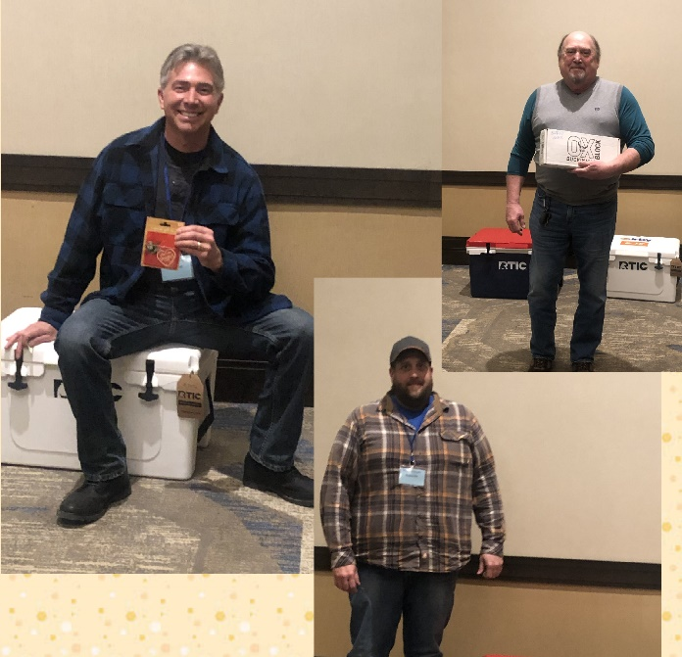
State Budget
As of today, April 4th, the state budget is still being worked on and developed. There doesn’t appear to be any items that will hold up the process too long as we expect to see parts of the finalized budget plan later this week around April 6th or 7th, if what we are hearing out of Albany is correct. Stay tuned for the final budget report next month.
Audit & Budget Committee
The Audit & Budget Committee met on March 10th and reviewed the MEUA’s Financials for the 2021 timeframe. Pam Gilbert, Chair – Spencerport, Karen Carr – Spencerport, Mary Ann Henderson – Hamilton and Bryan white – Fairport/MEUA attended and preformed the review.
The Committee will give their report at the MEUA Semi-Annual Meeting April 13th.
Accounting & Financing Workshop
The Accounting & Finance Workshop will be May 10 – 11 in Syracuse.
The agenda is almost finalized and will be sent out with registration forms soon. Registration form enclosed.
Please plan on attending as the Committee is working hard to put on a great workshop.
Smart Connect Project (Jay Brew)
As previously noted, NYPA and National Grid filed separate applications at FERC for an Abandonment incentive for the Smart Connect Project (cost recovery if the project dies), On Friday and Monday, FERC conditionally approved the requests after noting that neither provided the information FERC requires to get the incentive, but it would rely on PSC findings in the Article VII cases.
Next, NYPA filed for additional rate incentives in early February in a docket in which MEUA has intervened. Finally, last week, National Grid made its companion incentive rate filing. Grid requests the following:
- Allocation and collection of the costs of the Project from all New York load-serving entities on a statewide, volumetric load ratio share basis. NMPC claims this allocation is appropriate because the Project is designated as a priority transmission project that benefits consumers across New York in various ways. This is the most objectional aspect of the filing form an MEUA perspective because it disregards the "beneficiary pays" principle previously followed.
- Approval of a cost of capital based on a 10.5% ROE. Grid claims this ROE is developed in accordance with FERC’s current ROE methodology. Informally, Grid wants the same ROE that NY Transco and NextEra received (i.e, around 9.5% plus the incentives).
- Transmission rate incentives:
  - A 50 basis point ROE Risk Adder representing the risks and challenges not readily accounted for in Grid’s base ROE;
  - A 50 basis point ROE adder for participating in an RTO, or alternatively, a 50 basis point adder based on benefits provided to customers;
  - Recovery of 100% of prudently incurred costs for construction work in progress in rate base; and
  - A performance-based rate ROE adjustment associated with the implementation of the cost containment commitment (discussed below), which would add 5 to
71 basis points to ROE based on Grid’s ability to develop the Project below the Cost Cap.
In total, Grid seeks a total ROE of 11.5%, but this may increase if the Company also receives the performance-based rate ROE adjustment to anywhere between 11.5% and 12.21%. claims that these incentives are justified based on the risks and challenges in developing the Project.
The cost recovery will be accomplished by adding to the NYISO tariff a new Smart Path Connect Facilities Charge (SPC-FC).
The MEUA has intervened to protest the requested ROE and cost allocation.
Thank you.
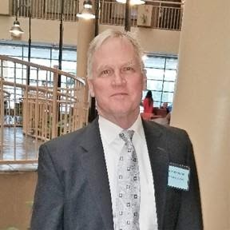
Chris Wentlent: MEUA Advisor

March 2022

NYISO Update – April 2022

New York Independent System Operator (NYISO) Update
NYISO Buyer Side Mitigation (BSM) Filing – The Federal Energy Regulatory Commission (FERC) issued a deficiency letter with questions. On March 11, the NYISO responded to the letter and is awaiting the FERC’s response. This docket is important because it will impact how clean energy resources are transitioned into the NYISO Capacity Market, and how to properly quantify how the capacity value of those resources is determined to ensure system reliability is maintained.

Transmission Update
Long Island OSW Submittals – The NYISO made a presentation at the March 1 TPAS/ESPWG Meeting. The projects that met the viability and sufficiency criteria were identified. In total nineteen projects/four Developers were proposed. Sixteen projects were deemed viable and sufficient. Developers must now provide notice of their intent to proceed with the evaluation of their viable and sufficient Public Policy Transmission Projects for purposes of NYISO selection of the more efficient or cost-effective project. This process will take through CY 2022 at a minimum to finalize the successful bidder.

Other Transmission
- The WNY Empire Transmission upgrade will be completed by May/June 2022 which will help reduce Zone A congestion.

- The Segment A & B AC Transmission Public Policy Projects and the first phase of NYPA North Country MA1 and MA2 are not expected to be completed until the end of 2023.

- NYPA/NGRID Second Phase Accelerated Transmission Project is a 2025 expected completion date. Together, this grouping of projects will reduce upstate transmission congestion and allow more renewable generated megawatts to flow to the high-density population areas downstate.

- NYPA and National Grid filed separate applications at FERC for an Abandonment incentive for the Smart Connect Project (cost recovery if the project does not proceed), On March 11, and March 14, FERC conditionally approved the requests after noting that neither filing provided the information FERC requires to get the incentive, but it would rely on PSC findings in the Article VII cases.

  - NYPA filed for additional rate incentives in early February.
  - National Grid also made its companion incentive rate filing. Grid requests the following:
  - Allocation and collection of the costs of the Project from all New York load-serving entities on a statewide, volumetric load ratio share basis. NGRID claims this allocation is appropriate because the Project is designated as a priority transmission project that benefits consumers across New York in various ways. Some parties will argue the “beneficiary pays” approach should be followed.
  - Approval of a cost of capital based on a 10.5% Return on Equity (ROE). Grid claims this ROE is developed in accordance with FERC’s current ROE methodology.
  - NYMPA has intervened and filed comments in this proceeding. Our major areas of consideration are cost allocation, Return on Equity, and rate incentives.

  - Con Ed Peaker Rule Transmission Upgrades for three networks still on schedule for 2023 and 2025.

Climate Action Council Update –
New York State’s 22-member Climate Action Council, established under the Climate Leadership and Community Protection Act (CLCPA), will hold ten public hearings across the State to receive public input on the Draft Scoping Plan and advance work on a Final Scoping Plan to guide the implementation of the State’s nation-leading climate goals under the CLCPA.
The Council released the Draft Scoping Plan on December 30, 2021 and is accepting public comments on the draft through June 10, 2022. The Council extended the comment period beyond 120 days to allow for additional public input.
Co-Chairs of the Climate Action Council announced eight in-person hearings in locations across the State, as well as two virtual hearings. In-person hearings will also be live-streamed to allow for remote viewing of the proceedings. All persons, organizations, corporations, and government agencies are encouraged to attend the public hearings and to submit oral or written comments. MEUA will present comments at the April 26 Syracuse Meeting, and possibly the May 10th Tupper Lake Meeting. In addition, we are considering joint comments as part of our involvement in the Utilities Consultation Group (UCG); a group we have collaborated with throughout the Climate Action Council process.

Date | Time | Location | Venue
Tuesday, April 5, 2022 | 4:00 PM | Bronx | Bronx Community College  Roscoe Brown Student Center  Hall of Fame Playhouse  2155 University Avenue  Bronx, NY 10453
Wednesday, April 6, 2022 | 4:00 PM | Brookhaven | Brookhaven Town Hall  1 Independence Hill  Farmingville, NY 11738
Tuesday, April 12, 2022 | 4:00 PM | Binghamton | Binghamton University  Symposium Hall  85 Murray Hill Road  Vestal, NY 13850
Thursday, April 14, 2022 | 4:00 PM | Albany | Empire State Plaza  Meeting Room 6  Albany, NY 12242
Tuesday, April 26, 2022 | 4:00 PM | Syracuse | SUNY College of Environmental Science and Forestry  Gateway Center  1 Forestry Drive  Syracuse, NY 13210
Wednesday, April 27, 2022, | 3:30 PM | Buffalo | Buffalo & Erie County Public Library  Mason O. Damon Auditorium  1 Lafayette Square  Buffalo, NY 14203
Tuesday, May 3, 2022, | 4:00 PM | Brooklyn | New York City College of Technology  The Theater at City Tech  285 Jay Street  Brooklyn, NY 11201
Saturday, May 7, 2022, | 10:00 AM | VIRTUAL | Event link: https://nyserdany.webex.com/nyserdany/onstage/g.php?MTID=e3f037513c7ab055c46f1253fb908265e  Event number: 2599 706 6384  Event password: climate  Call in number: +1-415-655-0003  Call in access code: 2599 706 6384
Tuesday, May 10, 2022, | 4:00 PM | Tupper Lake | The Wild Center  45 Museum Drive  Tupper Lake, NY 12986
Wednesday, May 11, 2022, | 4:00 PM | VIRTUAL | Event link:  https://nyserdany.webex.com/nyserdany/onstage/g.php?MTID=eecfcf639bf8b5c07f1740e976f494fba  Event number: 2595 530 3236  Event password: climate  Call in number: +1-415-655-0003  Call in access code: 2595 530 3236

Additional steps in the Climate Action Council process include:

Now until May – information gathering
  - Public comment period
  - Engagement with Climate Justice Working Group
  - Develop & launch communications & educational materials
  - Expert engagement – natural gas transformation, alternative fuels, carbon pricing or other funding mechanisms, timing and sequencing.

June to August – discussions & deliberation
September to December – drafting and Scoping Plan finalization

New York State Public Service Commission
- PSC’s Transmission Planning Proceeding – 20-E-0197. In addition to OSW directives above; the Power Grid Study Order also directs Transmission Owners (TOs) to create a collaborative for integration of advanced technologies. It is required by July 2022. A committee will be formed to evaluate projects including TOs, Department Public Service, NYSERDA, and other market participants. MEUA is part of the committee formed. This will allow us to fully understand the expected planning process going forward and evaluate the impact on our municipal systems.

NYSERDA
- On March 9, New York State released the Draft Disadvantaged Communities Criteria to Advance Climate Justice Plan. The plan is subject to public hearings and a written comment period before finalized. The draft plan identified the official list of Disadvantaged Communities for consideration. This is important because these communities will receive up to 40% of clean energy benefits. The information distributed does identify some sections of our municipal systems that would qualify under the Disadvantaged Community Criteria Metrics utilized. Additional information is available at: https://www.nyserda.ny.gov/About/Newsroom/2022-Announcements/2022-03-09-New-York-State-Releases-Draft-Disadvantaged-Communities-Criteria
RGGI
- The eleven participating states in the Regional Greenhouse Gas Initiative (RGGI), the nation’s first market-based regulatory effort to reduce greenhouse gas (GHG) pollution, announced the results of their 55th auction of carbon dioxide (CO₂) allowances on March 11. Virginia did participate in the recent auction. 21,761,269 CO₂ allowances were sold at the auction at a clearing price of $13.50. Bids for the CO₂ allowances ranged from $2.44 to $30.00 per allowance. Additional details are available in the Market Monitor Report for Auction 55. The RGGI Program is currently under a re-evaluation stage. The RGGI allowance monies collected are used for clean energy projects throughout the eleven states. New York State has its own RGGI Operating Plan.
MEUA Municipal Member EMPLOYMENT ADVERTISEMENTS:
Full descriptions listed on our website — www.meua.org

Skaneateles: Electric Line Leader

The Village of Skaneateles is seeking a full-time line leader for our electric department. This is a non-competitive civil service position involving overhead and underground work on our distribution system. Work will also involve other Village duties as necessary.

Qualifications include 4 years of Journeyman level work, with all certifications. Knowledge of distribution electric systems and substations. Ability to plan, develop strategies and implement ideas for crew leadership while performing line construction duties. Must have the ability to direct subordinate employees.
This is a Union position with the benefits commensurate with negotiated contracts. Salary commensurate with contract.

Mail resume to Laurie Walter, Village Clerk, 26 Fennell St., Skaneateles, NY 13152.

Penn Yan: Electric Lineworker

The Village of Penn Yan Municipal Electric Department is seeking candidates for the full-time position of an experienced Electric Lineworker.

Primary Responsibilities

- Engaged in any type of construction, operation or maintenance on distribution lines and associated equipment.
- Apply safety rules and regulations as they apply to line substation and service work.
- Installs, inspect and repair poles, conductor, transformers, meters, hardware and other equipment on or near energized and de-energized lines in keeping with the appropriate specifications.
- Respond to outages to investigate, locate, analyze, correct faults and restore service on distribution equipment.
- Perform line switching, including switching at a transformer or automatic air-switch station.
- Reviews plans and specifications.
- Inform supervisors of equipment and materials required to complete jobs.
- Trains other crew members in construction of electrical distribution systems.
- Performs basic maintenance on equipment.
- Other responsibilities as assigned.
- New York State Disability Insurance
- 12.5 paid holidays on top of time earned
- NYS Employees Retirement System
- Flexible shifts Monday-Friday with on-call availability

Keys to success include working effectively with a team, following safety protocol, being respectful to others, and having integrity and pride in your work.

Minimum qualifications include graduation from high school or possession of a high school equivalency diploma; AND four (4) years of full-time or equivalent part-time paid work experience as an Apprentice Lineworker on electric distribution systems; OR one (1) year of full-time or equivalent part-time paid work experience as an Electric Utility Lineworker. (Must possess Qualified Electric Person (QEP)). This is a competitive NYS Civil Service position that is full time, 40 hours per week and subject to Civil Service rules for eligibility.

Interested applicants should apply by Friday 2/21/2022 by submitting an application to the Yates County Personnel Office at 417 Liberty St, Penn Yan, NY 14527 or online at https://mycivilservice.yatescounty.org/jobopps.

Village of Churchville: Electric Dept. Bookkeeper

The Village of Churchville is hiring a full-time Electric Bookkeeper to undertake a wide variety of electric booking duties, general ledger reconciliation, monthly utility billing, and various office duties.

An Electric bookkeeper is well organized and professional with excellent communication skills. The successful candidate will be a self-starter who is highly motivated and exhibits a demonstrated ability to learn. Two years’ experience in a fast-paced office environment using Microsoft Office (Word, Excel, Access, and Outlook) is required, along with a background in accounting. The ability to multi-task and prioritize work is a must. The candidate will also have a strong attention to detail, possess excellent time management and problem-solving skills, and be reliable and patient. Experience in a municipal office environment is preferred.

The Village of Churchville offers a comprehensive benefits package including health, dental, and vision coverage, paid vacation and sick time, and New York State Retirement. Starting pay will be based on experience.

Applications are being accepted until June 18, 2022 or until the position is filled. Applications and resumes may be brought to the Village Office or mailed to:

Mayor John Hartman
Village of Churchville
23 E Buffalo St
PO Box 613
Churchville, NY 14428

Registration Form

