Executive Director Report

Pic

Happy New Year everyone, hope your holiday season was a great one – welcome 2022.

**BILL WHITFIELD, WELLSVILLE RETIRES**

Bill Whitfield, Wellsville has retired as of December 31st. Director of the Department of Public Works for Wellsville for many years, Bill is looking forward to enjoying family time and vacationing with his wife Cathleen.

A two-time President of the MEUA, Bill was currently serving his last year of the Executive Committee as a Trustee at the time of his retirement.

Always one to help out, Bill’s leadership on the Executive Committee and to the MEUA will be missed.

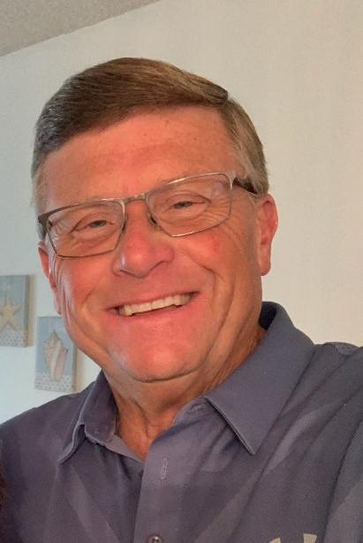Thank you, Bill, for your commitment to the MEUA and its member systems, you will be missed as your opinion was always valued and listened to. Good luck in your retirement, may you enjoy as you truly deserve it.

Since Bill was in the middle of his last year on the Executive Committee, the Bylaws state the following for his replacement.

In accordance with the current MEUA Constitution and Bylaws September 2020 Edition, the vacant Trustee position will be filled per Article III, Section 10. Article III, Section 10 states: “Should a Trustee move from State, become deceased, or resign for any reason, the Executive Committee, by a majority vote, shall appoint his successor, who shall be a Past President. If no Past President is eligible or willing to serve as Trustee, the Advisory Committee shall be asked to nominate a member of the Advisory Committee to the Executive Committee for approval”. No deadline is stated in the Bylaws regarding filling the vacated position of Trustee upon Trustee Whitfield resignation effective December 31st, 2021.

**LARRY KILBURN, ARCADE AGREES TO SERVE**

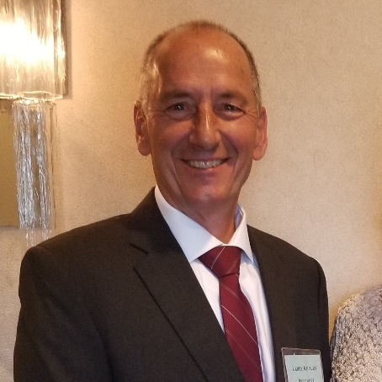Larry Kilburn, Arcade has agreed to serve the remaining months of the Trustee position.

This position will then be filled by the normal election process at the next Annual Meeting in 2022.

Thank you, Larry, for agreeing to serve once again and good luck. The Executive Committee looks forward to working with you. Larry, also a two-time President of the MEUA was last President in 2017 – 2018.

**BOONVILLE SUBSTATION EMERGENCY**

On Saturday Dec 11th the Municipal Commission of Boonville experienced a failure/fire associated to a switch gear within our substation. The fire was put out and power was restored within 20 minutes utilizing a spare feeder within that gear that wasn’t damaged due to fire. Through reaching out to the MEUA, William Tracey from Plattsburg, Bryan White and Matt Hegarty from Fairport Electric it was made very clear assistance was available. Fairport Electric immediately sent line foreman Brent Losey and Meter Specialist Ryan Trinkl to our substation to evaluate the situation and devise a plan for temporary repair. Matt was able to take those plans gather the needed materials and schedule these repairs for Thursday Dec 16th. Fairport Electric (Brent, Chris, Jeff, Chris, Tony, Tim and Matt) arrived in Boonville around 10am and left our substation around 4:30pm with all necessary work being completed. Boonville Municipal had an outage scheduled from 11pm Thursday Dec 11th to transfer these circuits and feed power from a different switch gear. Boonville shut down at A stage with a crowd watching
exactly 11pm and power was restored at 11:09pm making the total outage duration to our customers from the switch gear failure/fire less than 30 minutes. This would not have been possible without the systems our organizations have implemented throughout the years when it comes to mutual aid.

Thanks Rob Schneider

Boonville Electric & Water Superintendent

**SPENCERPORT WIND STORM AND MUTUAL AID**

On Saturday, December 11th wind gusts of 65-70 mph came through the western towns and suburbs of Rochester hitting the Village of Spencerport Municipal Electric franchise area approximately 4:30 PM. It was soon determined that this storm would be categorized as the most significant event to impact Spencerport since the infamous 1991 Ice Storm. Every storm is different, and while this one did not spread system wide interruptions to SME’s 3,200 Customers, it did cause extreme damage in 7 different locations within the franchise with backyard broken poles, primary and secondary wires down, transformers damaged, etc., all caused by fallen trees.

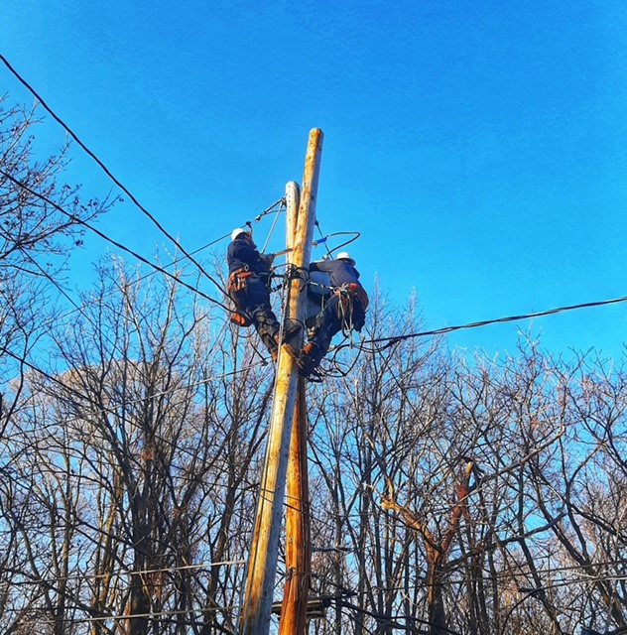

**Crew Readiness:**

To prepare and minimize expected emergency call response times, SME crews were brought into work prior to the storm front hitting the area. Once the front came through SME Crews responded to numerous locations throughout the night by isolating and making safe downed power lines. Initially no restoration efforts were made however instead SME crews performed damage assessment into the midnight hours realizing that damaged backyard areas would take restoration times estimated at 8-10 hours at each location.

**MEUA Mutual Aid:**

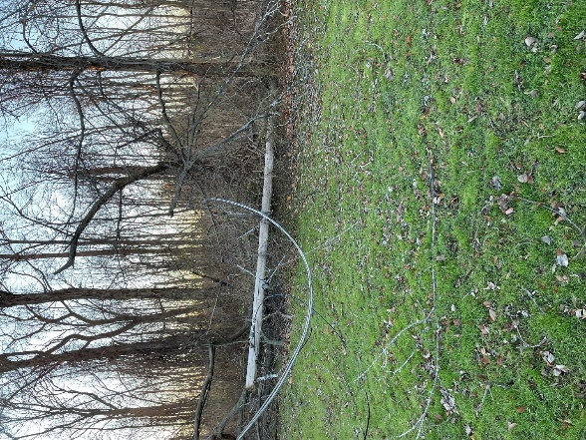We decided as a group that bringing in multiple crews during daylight hours would be the best approach for safe and timely restoration, so late Saturday night requests were made to our MEUA Western & Central Regional Liaisons, (Matt Campbell & Jeff Livingston) for MEUA Crews, specifically for all rear lot climbing and rigging experience.

By 7:00 AM Sunday MEUA crews arrived from the Village of Arcade, Churchville, Fairport, Greene, Groton, Marathon and Springville. Our normal workforce of 5 employees quickly swelled to 25 Line Workers. Matt Hegarty was generous to send over one of Fairport’s Rear Lot Pole Setters, so along with Spencerport’s, we had 2 backyard machines to utilize. After tailboard discussions on safety and operating procedures, Mutual Aid Crews were given assignments with circuit maps and damage assessment information on specific jobs and went to work. For the most part all the damaged areas were in backyards, which required all climbing, so all the shiny nice-looking unoccupied bucket trucks were parked at the roads.

**Customer Outages:**

An estimated 115 Village of Spencerport residential customers and 125 Town of Ogden customers were without power from 4:30 PM Saturday through 8:30 PM Sunday evening. One Elementary School and a Monroe County Pure Waters Pump Station were off similar times. During Sunday, hundreds of additional Village customers were without power for hours as we de-energized Circuits due to some dangerous situations during restoration efforts. The Spencerport Village Office was staffed the entire time and assisted Customers with providing realistic restoration times.

Villages of Greene, Groton, and Marathon stayed Sunday night in a Brockport Hotel and assisted SME on Monday with final restorations. Churchville also returned to SME on Monday.

**Thank You:**

I’d like to extend a very special thanks to our MEUA Mutual Aid crews and SME employees for remaining safe, establishing excellent work area protections, following strict OSHA and SME Operating procedures all the while restoring power in a quick efficient safe manner.

It's very encouraging to know that we have such great dedicated and experienced Line Workers throughout our MEUA and to know that they are only a phone call away. Many thanks to all!!!

Respectfully submitted, Owen McIntee-Spencerport



**Chris Wentlent: NYISO Advisor**

**November 2021**

**NYISO**

Happy New Year to all our municipal systems and your families. I hope 2022 is filled with health and happiness.

**New York Climate Action Council**

Climate Action Council Update – the Climate Action Council is scheduled to meet on December 20, 2021, to vote on the final draft Scoping Plan to be released to the public. The next step in the process will be a public comment period and a minimum of six public meetings. The draft Scoping Plan must be finalized by December 31, 2022. I will provide a complete summary in our February 2022 News & Views. Some key areas that will likely be in the draft Scoping Plan include a natural gas transition section, whether some form of carbon pricing should be adopted, acceleration of building heat retrofits to air source and ground source heat pumps, acceleration of electric vehicles, complete phase out of fossil fuels by 2040 in the generation sector, possible ban on fossil fuel appliances (heating, cooking, hot water) by a set date for new buildings, phase out of fossil fuel appliances by a grandfathered date for existing buildings, and additional emphasis on CO2 sequestration in soil management and timber management.

The IEEP/MEUA will host two Climate Action Council webinars (same presentation) to our municipal Commercial & Industrial customers in January 2022 on this matter. The purpose of the online seminar is to provide a more detailed overview of the Climate Action Council process, and how the process could impact commercial and industrial businesses going forward. We will also outline IEEP programs that may benefit these types of customers.

**New York State Reliability Council (NYSRC)**

The New York State Reliability Council (NYSRC) approved its’ Internal Reserve Margin for the New York Control Area at 19.6%. This is 1.1% lower than last year. The reasons for the reduction were better load forecast certainty, reduced load demand in Zone J (NYC), and better modeling of energy limited resources. The reduction from 20.7% to 19.6% will reduce our capacity market obligations for the May 2022-April 2023 Capacity Capability Year. MEUA is a member of the New York State Reliability Council.

**New York Independent System Operator (NYISO)**

The NYISO Board of Directors and Management Committee approved the Comprehensive Reliability Plan (CRP) – the plan states the New York Control Area is reliable through the 2030 timeframe subject to planned transmission being completed and the generation portfolio is not impacted negatively by unit retirements. However, for the period 2030-2040, major concerns are generated due to the changing resource mix in New York State due to the Community Leadership and Community Protection Act (CLCPA). Specifically, traditional 24/7 resources will be replaced by a higher percentage of intermittent resources. This changing mix could lead to supply/load gaps seasonally, weekly and even within the same day. In addition, a massive amount of transmission and distribution upgrades will be necessary to transport this energy onshore and from offshore.

Transmission – The WNY Empire Transmission upgrade will be completed by May/June 2022 which will help reduce Zone A congestion. The Segment A & B AC Transmission Public Policy Projects and the first phase of NYPA North Country MA1 and MA2 are not expected to be completed until the end of 2023. Finally, the NYPA/NGRID Second Phase Accelerated Transmission Project is a 2025 expected completion date. Together, this grouping of projects will reduce upstate transmission congestion and allow more renewable generated megawatts to flow to the high-density population areas downstate.

**NYSERDA**

Governor Hochul Announced the Launch of Multi-Year Study to Explore How Climate Change Affects New York State Communities, Ecosystems, and the Economy. This collaborative climate research effort led by the New York State Energy Research and Development Authority's (NYSERDA) and conducted in partnership with academic institutions, science organizations, community leaders and industry representatives, among others, to better understand and document the current impact of climate change across the state, what future impacts may be, and how the state can better prepare for them. Taking action to adapt to future climate conditions supports the implementation of the State's Climate Leadership and Community Protection Act (CLCPA). Eight technical working groups will lead the Assessment, including searching and critically reviewing the best available scientific literature, incorporating new projections, and developing the technical report. Each workgroup is led by two co-chairs and has been tasked with examining climate change impacts in one of the following eight sectors: agriculture, buildings, ecosystems, energy, human health and safety, society and economy, transportation, and water resources. NYMPA/MEUA (Chris Wentlent) will serve in an Advisor capacity for the energy sector working group.

**New York Legislature**

The New York Legislature introduced a bill to study transition the Long Island Power Authority (LIPA) from a third party operated system to 100% public power when their current contract with Public Service Electric & Gas expires. The legislation proposes a Legislative Commission and Advisory Commission be formed to study it and make recommendations.

**Executive**

Governor Hochul is scheduled to present her first State of State Address on January 5, 2022. I will provide any energy or environmental updates in our next monthly column.

**MEUA MUNICIPAL MEMBER EMPLOYMENT ADVERTISEMENTS:**

Full descriptions listed on our website —[**www.meua.org**](http://www.meua.org)

**Angelica: Electric Lineworker**

Electrical Lineworker – The **Village of Angelica**, Electric Department is presently accepting applications to fill a vacancy in the Municipal Electric Department.  This position will require climbing skills, working with high voltage electric and will encounter working at considerable heights in possible adverse conditions.  The position will also require completion of a 4-year apprentice Lineworker program as set forth by the Municipal Electric Utilities Association.

Applications will be accepted at the Village of Angelica, Village Office, 21 Peacock Hill Rd, Angelica, NY 14709. The Village of Angelica is an Equal Employment Opportunity Employer.

**Solvay: Assistant Electric Department Superintendent**

Salary Range: $75,000-85,000 Annually

**Job Description:**

The work involves responsibility for assisting in the daily management and supervision of the Village of Solvay Electric Department. An employee in this class is responsible for scheduling and directing the day-to-day and long-term activities of various departments and the crews. Under general supervision of the Electric Department Superintendent, an employee in this class carries out work in accordance with general policies of the Village Board of Trustees and its Electrical Committee with wide leeway for the exercise of independent judgment in carrying out technical duties of the work. General supervision is exercised over a large number of technical and clerical subordinates. An employee in this class is required to be on call at all times in order to direct staff during emergencies. Does related work as required.

**Minimum Qualifications:**

Five (5) years of professional supervisory level work experience, or its part-time equivalent, in business management which must have included operations planning and job cost analysis, while working or contracting for a municipal or private electric power company.

NOTE: Electrical contracting work must have been with a municipal or private electric power company.   
Home, building construction or industrial contracting does not qualify.

**Please email resume and references to** [**hdecarlo@villageofsolvay.com**](mailto:hdecarlo@villageofsolvay.com) **for consideration.**

**Skaneateles: Electric Line Leader**

The Village of Skaneateles is seeking a full-time line leader for our electric department. This is a non-competitive civil service position involving overhead and underground work on our distribution system. Work will also involve other Village duties as necessary.

Qualifications include 4 years of Journeyman level work, with all certifications. Knowledge of distribution electric systems and substations. Ability to plan, develop strategies and implement ideas for crew leadership while performing line construction duties. Must have the ability to direct subordinate employees.

This is a Union position with the benefits commensurate with negotiated contracts. Salary commensurate with contract.

Mail resume to Laurie Walter, Village Clerk, 26 Fennell St., Skaneateles, NY 13152.