Executive Director Report

Pic

MEUA 91st Annual Conference

Thanks to the members, spouses and corporate members who attended and helped make the Annual Conference a successful one. It sure was nice to see people together again and getting reacquainted after such a long time of not being able to.

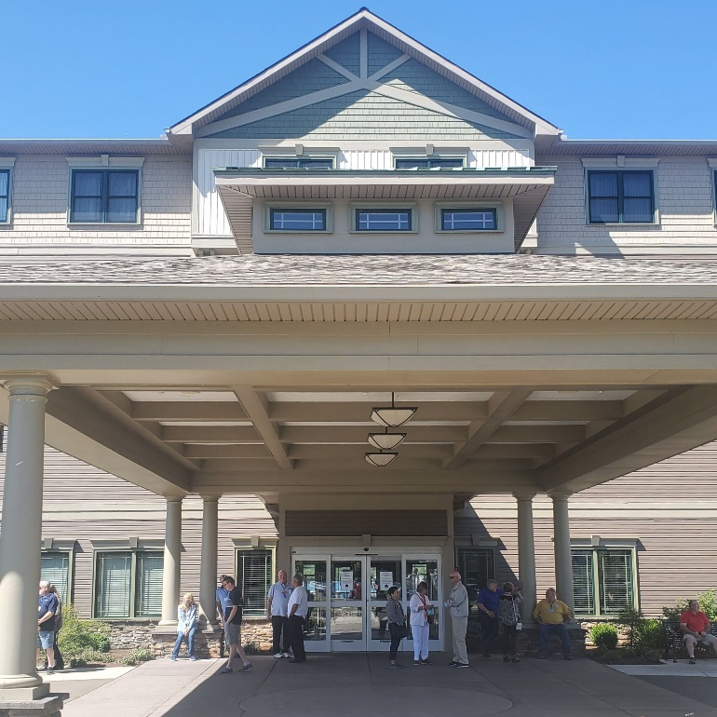

The Chautauqua Harbor Hotel proved to be a great venue with picturesque grounds, great service, and delicious food.

The corporate members were numerous with 27 tables of products, tools and clothing. Thank you all for your continued support.

I’d like to thank our panel of consultants for their informative presentation on energy issues in New York State and at the federal level. Ken Podolny of Read and Laniado, Jay Brew of Stone Mattheis Xenopoulos & Brew, PC, Chris Wentlent of Wentlent LLC and Mark Cordeiro of PLM did an excellent job presenting this important update to the membership.

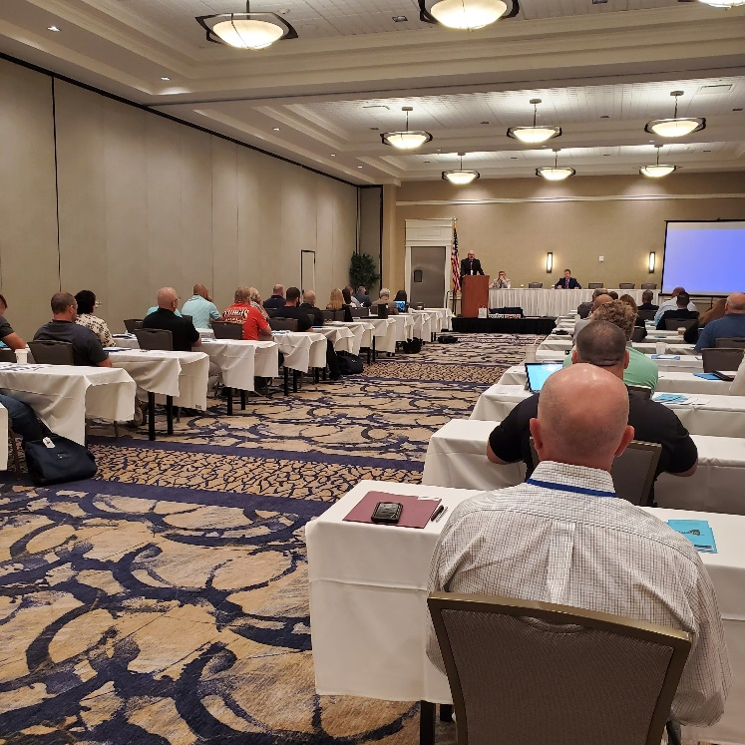

Also, thank you to John Jennings of Harter Secrest & Emery LLP for his update on the Governorship and Legislature as the state moves forward under Governor Hochul.

MEUA Executive Committee 2021-2022

The MEUA Executive Committee is as follows for the next year:

President Nancy Mitchell, Hamilton
President-Elect Andrew Thompson, Westfield
VP/Treasurer Bryan White, Fairport
VP/Secretary Robert Schneider, Boonville
Trustee William Whitfield, Wellsville

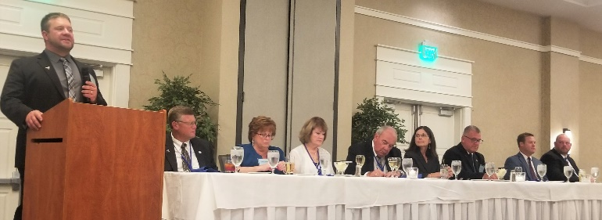

Congratulations to all for your commitment. Nancy Mitchell becomes the 2nd female President of association and also the 2nd female President named “Nancy”. (Nancy Steedman, Churchville, MEUA President: 2016-2017)

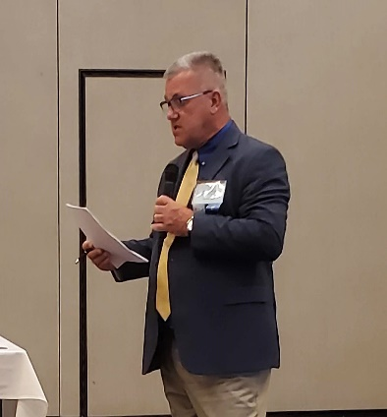
Owen McIntee, Spencerport, finished his 1-year appointment to the Board and chose not to run again this year.
Owen McIntee has proven to be a great Executive Committee Member— we thank you for the years of service to the MEUA and look forward to your continuing work on the Safety & Training Committee and Mutual Aid.

Andrew Thompson, Westfield, agreed to fill Owen’s position and assumes the President-Elect position for this year. Thank you to Andrew for agreeing to continue to serve.

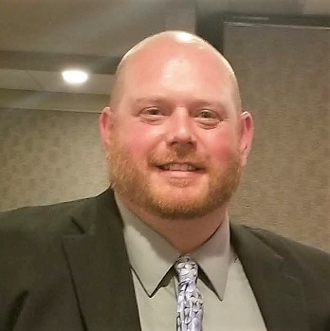
We welcome Robert Schneider, Boonville, to the Executive Committee and look forward to working with him.

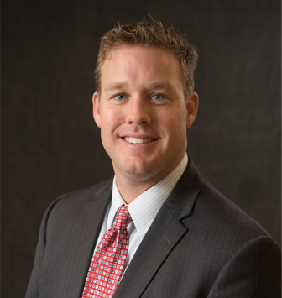

Bryan White, Fairport, continues on for his second year, moving up to Treasurer.

Non-Delegate Activities

Wednesday afternoon participants took the Chautauqua Belle Steamboat and toured Chautauqua Lake. The lake is approximately 19 miles long and with its beautiful views, offers a memorable experience. The Chautauqua Belle is one of five real life steamboats left in North America.

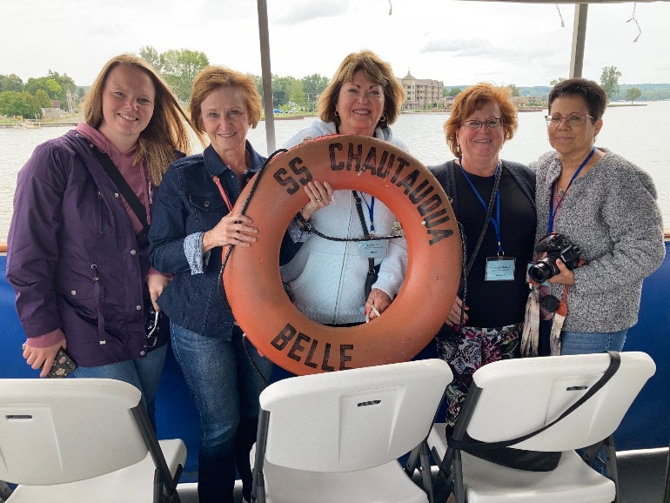

On Thursday afternoon participants went to the National Comedy Center in Jamestown, which is also Lucille Ball’s hometown. The museum documents the history of comedy and the artists, producers, writers, cartoonists and other notable figures who have influenced the development of comedy in the United States.

The comedy center was recently named the “Best New Museum” in the country by USA Today and one of the “World’s Greatest Places” by TIME Magazine.

Bill & Cathleen Whitfield

A big thank you goes to past president Bill Whitfield and his wife Cathleen for all the hard work, planning and devotion to this year’s Annual Conference. Cathleen did an amazing job hosting the morning meeting for the non-delegate members, and worked to coordinate activities for the spouses.

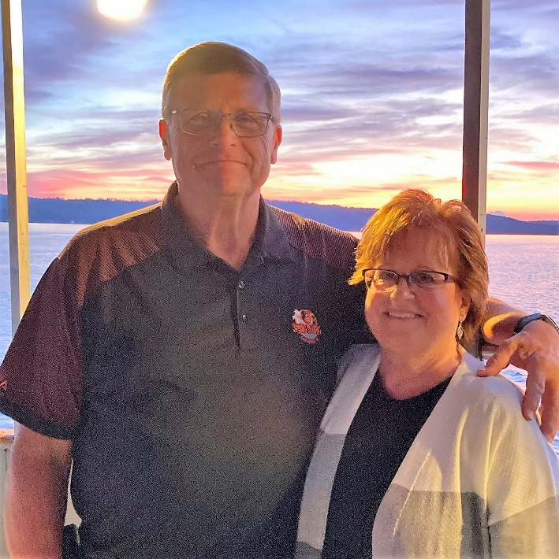

Unless you have planned for an Annual Conference, you don’t know the work that goes into seeing that all details are worked out which included the non-delegate events, etc. Thank you to Cathleen and Bill for seeing this through.

Great job!!!

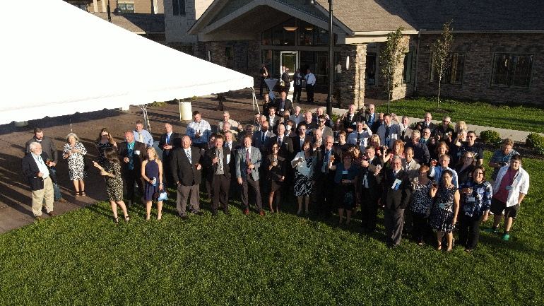

The Westfield Fund

The 2021 MEUA Charity Golf Tournament at the Annual conference proved to be a great event. Good weather and good turnout— Thank you Kevin Brocks, Read and Laniado, for once again sponsoring this annual event.

Between the Charity Auction and the golf collection, proceeds a check for $2,308 was presented to Al Holbrook of The Westfield Fund.

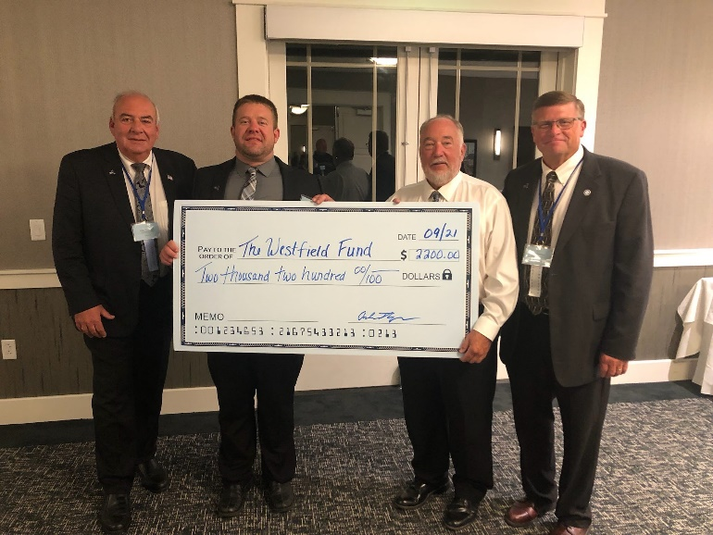

Thank you all who brought gifts towards the auction and to all who supported the effort.

Thank you.

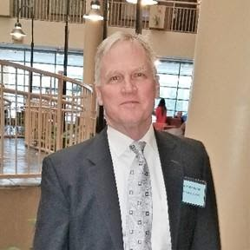
Chris Wentlent: NYISO Advisor
September 2021

Happy Fall and I hope everyone had an enjoyable summer.
Climate Action Council – Reliability Planning Speaker Series Summary
In previous columns, I outlined that the Climate Action Council is tasked with creating a Draft Scoping Plan that provides a roadmap for how New York State will meet the Climate Leadership and Community Protection Act (CLCPA) requirements. The Draft Scoping Plan must be completed by the end of 2021. In 2020, the public hearings will be held throughout New York State and the Scoping Plan must be finalized by the end of 2022.
Simply, the CLCPA requirements are the following:
- 70% renewable energy generation by 2030

- 100% zero carbon energy generation by 2040

- 85% economy wide greenhouse gas (GHG) reduction by 2050, with the remaining 15% covered by offsets.

The Climate Action Council’s Reliability Planning Speaker Session was held on Monday, August 2, 2021. Presenters included the New York State Reliability Council (NYSRC), New York Independent System Operator (NYISO), Utility Consultation Group, Department of Public Service (DPS), Vote Solar, and Utility Intervention Unit (UIU).
Some of the main reliability points made during the presentations included the following:
NYSRC
- System operators will need additional dispatchable and sustainable energy resources to manage the substantially different energy system to maintain reliability.

- The New York Internal Reserve Margin will increase substantially to meet reliability requirements.

- Some of the new clean energy resources rely on technologies that do not currently exist for a utility scale application.

NYISO
- The variability of meteorological conditions that govern the output from wind and solar resources presents a fundamental challenge to relying on those resources to meet electricity demand.

- Battery storage resources help to fill in voids created by reduced output from renewable resources, but periods of reduced renewable generation rapidly deplete battery storage resource capabilities.

- The current system is heavily dependent on existing fossil-fueled resources to maintain reliability. Eliminating these resources will require investment in new and replacement infrastructure, and/or the emergence of a zero-carbon fuel source for thermal generating resources.

- Transmission investment, at both bulk and local levels, will be necessary to efficiently deliver renewable power to New York consumers.
UCG
- Transition to a clean energy future is feasible, but must be orderly, responsible and cost effective.

- A robust and dynamic transmission and distribution grid is critical to managing the complexity of intermittent renewable resources.

- Reaching CLCPA targets requires keeping “all options open”.

- Energy systems are complex and require extensive long-term planning.
DPS
- The electric system is complex; various capabilities and attributes are needed to maintain reliability including:

- An adequate amount of generation resources to meet consumer demands is needed to maintain reliability.

- A diverse resource fleet combining both intermittent and dispatchable resources is needed to maintain reliability.
- Future load shapes could lead to a need for fast ramping resources to follow real-time demands.

- A need will continue to exist for Black Start resources to bring the system back online in the event of a blackout.

- With large amounts of renewables being added to the system, particularly significant amounts of offshore wind into NYC and Long Island, the way that power flows across New York’s electric grid will change, impacting the way the grid is reliably operated and planned in the future.

Vote Solar
- Reliability is paramount, particularly for vulnerable communities in climate crisis.

- Integrating renewables into the grid while maintaining reliability is possible, and in fact cost-effective.
UIU
- How are the decisions now going to impact pries in the future and adoption of electrification?

- Are there any new technologies or improvements to existing technologies?

- One Constant – Load and Generation must balance.

The Climate Action Council Draft Scoping Plan will require a delicate balance of maintaining consumer cost affordability, introducing a large percentage of new zero carbon resources, building out the existing transmission and distribution systems; balancing load and generation to keep the lights on, and protecting public safety. The final plan must have realistic timeframes and maintain all options for compliance to meet the aggressive 2030, 2040, and 2050 requirements listed above.

MEUA MUNICIPAL MEMBER EMPLOYMENT ADVERTISEMENTS:
Full descriptions listed on our website — www.meua.org
Angelica: Electric Lineworker

Electrical Lineworker – The Village of Angelica, Electric Department is presently accepting applications to fill a vacancy in the Municipal Electric Department. This position will require climbing skills, working with high voltage electric and will encounter working at considerable heights in possible adverse conditions. The position will also require completion of a 4-year apprentice Lineworker program as set forth by the Municipal Electric Utilities Association.

Applications will be accepted at the Village of Angelica, Village Office, 21 Peacock Hill Rd, Angelica, NY 14709. The Village of Angelica is an Equal Employment Opportunity Employer.

Penn Yan: Electric Lineworker

The applicant must be able to perform skilled work in the construction and maintenance of electrical overhead and underground distribution systems, including the rebuilding and maintenance of electrical substations. The work requires climbing poles, working in all kinds of weather conditions and rigid observance of safety precautions to protect the lives of themselves and others. Compensation rate is $38.71 to $42.69 hourly rate, dependent on years of experience, Penn Yan also offers a competitive benefits package.

Interested applicants should apply by submitting an application to the Yates County Personnel Office at 417 Liberty St, Penn Yan, NY 14527 or online at https://mycivilservice.yatescounty.org/jobopps.

