Executive Director Report

Pic

Greetings Everyone,
I am pleased to be writing my initial greeting to everyone as Executive Director. Tony has left some large shoes to fill and on behalf of all the members I want to thank Tony for his many years of dedicated leadership. Fortunately, Tony will remain a consultant to the organization, so we will continue to have the benefit of his expertise and experience.
We are able to do what we do only because of our dedicated member representatives and professional consultants. I look forward to getting out to visit you all as soon as I can. In the meantime, please don’t hesitate to reach out to me with any questions you may have. The Executive Committee is working jointly with the NYMPA Board to develop a survey to gauge the collective thoughts of the members as to how we can better serve our members. We plan to have that survey circulated by the first of June.
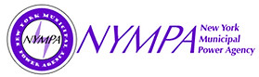
These are unsettling times in our country, and it is no different here in upstate New York. Energy markets are particularly volatile, and we are not immune from the effects of that volatility. Working with our consultants, we will do our best to guide the organization and the membership through the challenges ahead.
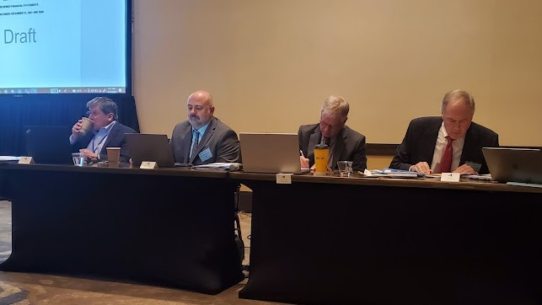
Semi-Annual Meeting
The MEUA Semi-annual meeting was held in Syracuse on April 12th and 13th. We had an engaging panel discussion with our consulting team, and heard from several very informative speakers, including:
Consultant Panel Members
(see above, left to right):
Mark Cordeiro, PLM
Ken Podolny, Read and Laniado
Chris Wentlent, NYISO Advisor
Kevin Brocks, Read and Laniado

Ken Pokalsky, Business Council of NYS
Wes Yeomans, NYISO
Darryl Jacobs & Rachel Gebhart, NYPA
Diane Burman, NYS Public Service Commission
Gavin Donahue (see below with Chris Wentlent), IPPNY

Thanks to Narin Kowalski, our corporate sponsors and everyone that worked to make the meeting and programming a success.

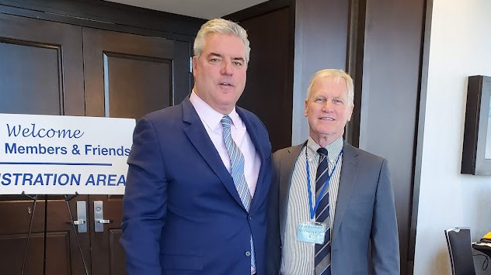

Accounting & Financing Workshop
The Accounting Workshop was held in Syracuse on May 10th and 11th with approximately 50 participants in attendance. I want to especially thank Narin Kowalski for her hard work and Bill Freitag and his colleagues from BST & Co., Holly Easling of Penn Yan, Aaron Daniels of Fairport and John Jennings of Harter Secrest & Emery for their generous assistance in making the workshop possible.
Annual Meeting – Save the Date!
The MEUA Annual conference will be held from September 6th through the 9th at the Marriott Syracuse Downtown Hotel. The 2022 conference theme is “Charging Into the New Normal”. Please keep an eye out for registration information that Narin will be sending out.
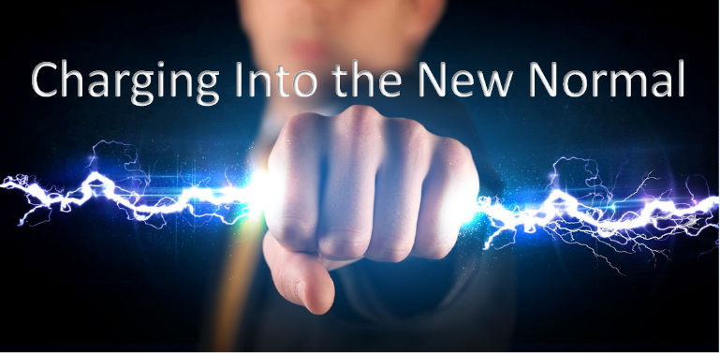
COVID Arrears Program
Thanks in great part to John Jennings of Harter, Secrest & Emory, funding is available from the State of New York to reimburse municipal electric utilities for certain account delinquencies related to the COVID restrictions on collection activities. Ken Podolny of Read & Laniado has also been working diligently on this program for the benefit of the members. Hopefully you have sent your account information. If you have any questions regarding the program, please contact the office.
State Legislation
With the assistance of John Jennings, Chris Wentlent and Ken Podolny, we are continually tracking pending legislative bills in Albany that may impact our members and, when appropriate, work to achieve amendments to protect our collective interests. One bill we are watching is S6843C, which would enact the "all-electric building act" to provide that the state energy conservation construction code shall prohibit infrastructure, building systems, or equipment used for the combustion of fossil fuels in new construction statewide no later than December 31, 2023 if the building is less than seven stories and July 1, 2027 if the building is seven stories or more. This was considered, but not enacted, as part of the Governor’s recent budget proposal.

Chris Wentlent: MEUA Advisor

May 2022

NYISO Update – May 2022

Climate Action Council Update –
New York State’s 22-member Climate Action Council, established under the Climate Leadership and Community Protection Act (CLCPA), is currently conducting public hearings across the State to receive public input on the Draft Scoping Plan and advance work on a Final Scoping Plan to guide the implementation of the State’s nation-leading climate goals under the CLCPA. The most recent meetings were held in Syracuse, April 26, and Buffalo, April 27. The Syracuse hearing began at 4pm and lasted until 715pm. Each speaker was allowed two minutes to provide an oral statement. Tony Modafferi and I attended. Stakeholders who presented included New York State Electric & Gas utilities, labor unions, business associations, building improvement contractors, environmental groups, local college professors, and some local college students.

The major themes of the presentations include cost and affordability for the electric consumer, capital cost dollars needed to make building, car, and appliance upgrades, maintaining electric system reliability, becoming overly dependent on the electric grid for all aspects of our individual day especially the impacts when the grid is not available, New York’s total impact is minimal compared to the entire world inventory, impacts on real estate values due to potential changing code requirements, climate is real and action is required now, hydrogen and renewable natural gas should or should not be part of the future resource mix, transmission and distribution must be built out to accommodate these proposed changes, timing and sequencing of planned changes, and natural gas should either be part of the picture or natural gas use should be ban for new buildings and eliminated over time.

The Council released the Draft Scoping Plan on December 30, 2021 and is accepting public comments on the draft through June 10, 2022. The Council extended the comment period beyond 120 days to allow for additional public input.
In addition, the Climate Action Council at its recent April 2022 meeting outlined they will create smaller sub-groups to evaluate the role of natural gas, role of alternative fuels such as hydrogen/renewable natural gas and how to pay for the entire draft scoping plan. To be clear, the costs of these anticipated changes will be in the tens of billions of dollars including full building renovations, new requirements for new structures, electric vehicle mandates and electric infrastructure buildout, electrical transmission and distribution required upgrades, and tens of thousands of new renewable energy resources to replace existing fossil-based generation. Finally, the reliability and resiliency of the plan is driven by a need to have at least 20,000 megawatts of zero carbon backup power to be available when intermittent resources are not available. This is particularly important during sun rise, and sunsets, wind lulls, seasonal fluctuations, and during the winter when we have minimal daylight hours.

Additional steps in the Climate Action Council process include:

- Now until May – information gathering
  - Public comment period
  - Engagement with Climate Justice Working Group
  - Develop & launch communications & educational materials
  - Expert engagement – natural gas transformation, alternative fuels, carbon pricing or other funding mechanisms, timing and sequencing.

- June to August – discussions & deliberation

- September to December – drafting and Scoping Plan finalization

New York State Public Service Commission

Energy Storage – 18-E-0130 – On April 4, the Department of Public Service (DPS) issued the third ‘State of Storage’ annual report announcing progress in reaching New York’s statewide energy storage goal of 3,000 megawatts (MW) by 2030, with an interim objective of deploying 1,500 MW by 2025. Energy storage enhances the efficiency of the electric grid through many different applications such as demand charge management, demand response, distribution system local reliability, firming large‐scale intermittent renewables, and wholesale market installed capacity and ancillary services, and supports the most aggressive climate-change goals in the nation, which puts New York on a path to economywide carbon neutrality. On January 5, 2022, Governor Kathy Hochul announced in the State of the State plans to double the State’s energy storage target to at least six gigawatts (GW) by 2030. DPS and the New York State Energy Research and Development Authority (NYSERDA) are in the process of updating the Energy Storage Roadmap to reflect the expanded goal. This updating exercise will likely lead to changes in the Energy Storage program.

Advancement of Distributed Solar - 21-E-0629 - Energy Mandate Increased from 6GWs to 10GWs – On April 14, Governor Kathy Hochul announced that the New York State Public Service Commission (NYSPSC) has approved a new framework for the State to achieve at least ten gigawatts of distributed solar by 2030, enough to annually power nearly 700,000 average-sized homes. The roadmap, submitted by the New York State Energy Research and Development Authority (NYSERDA) and the New York State Department of Public Service (DPS) to the Public Service Commission, provides a comprehensive strategy to expand the state's successful NY-Sun initiative into one of the largest and most inclusive solar programs of its kind in the nation.

The adopted framework includes an investment of $1.5 billion in ratepayer-funded incentives to extend the successful NY-Sun program and continue the marked reduction in project cost and incentives observed in the last ten years. The announcement supports the State's Climate Leadership and Community Protection Act (Climate Act) mandate to generate 70 percent of the state's electricity from renewables by 2030 as part of a resilient and equitable transition to a clean energy economy. The roadmap approved by the Commission and developed by Department of Public Service (DPS) and NYSERDA carefully evaluated multiple strategies to deploy ten gigawatts or more of distributed solar by 2030 and determined that extending the State's successful NY-Sun initiative provides the most efficient and cost-effective path forward.

Importantly, the now-approved roadmap provides:
- Enough new clean, renewable energy to annually power 700,000 additional homes;
- At least 1,600 megawatts, enough to power 280,000 homes of new solar capacity to benefit disadvantaged communities and low-to-moderate income New Yorkers, with an estimated $600 million in investments serving these communities;
- At least 450 megawatts, enough to power nearly 79,000 homes, to be built in the Con Edison electric service area (covering New York City and parts of Westchester), increasing the installed solar capacity in this area to over one gigawatt, enough to power nearly 175,000 homes;
- At least 560 megawatts, enough to power 98,000 homes, to be advanced through the Long Island Power Authority; and
- A new requirement that workers associated with the construction of NY Sun supported projects that are greater than one megawatt be paid the applicable prevailing wage.

Clean Energy Proceeding – 15-E-0302 – On April 14, Governor Kathy Hochul announced that the New York State Public Service Commission (NYSPSC) has approved contracts with Clean Path New York LLC for its Clean Path NY project and H.Q. Energy Services Inc. for its Champlain Hudson Power Express project to deliver clean, renewable solar, wind and hydroelectric power from upstate New York and Canada to New York City. The state's first-of-its-kind renewable energy and transmission projects are expected to deliver overall societal benefits statewide, including greenhouse gas reductions and air quality improvements, and economic development across the state, including investments in disadvantaged communities. As the largest transmission projects contracted for New York State in the last 50 years, these projects will reduce the city's reliance on fossil fuel-fired generation by more than 50 percent in 2030.

The NYSPSC's October 2020 order adopted a Tier 4 program as part of the NYSPSC's Clean Energy Standard with the purpose of increasing the penetration of renewables into New York City and directed New York State Energy Research Development Authority (NYSERDA) to conduct a Tier 4 solicitation. In January 2021, NYSERDA issued a Tier 4 renewable energy solicitation seeking projects that can cost effectively and responsibly deliver renewable energy to New York City, an area of the state that relies on aging fossil fuel-fired generation. The selected projects are expected to deliver eighteen million megawatt-hours of clean energy per year, or more than a third of New York City's annual electric consumption, from a diverse and resilient clean generation portfolio including onshore wind, solar, and hydroelectric power, backed by energy storage, from upstate New York and Quebec. With approval of the contracts, NYSERDA payments will commence for each respective project once the project has obtained all required permits and approvals, has completed construction, and is delivering power to New York City, which is expected to begin in 2025 for the fully permitted CHPE project and 2027 for the CPNY project. The costs of both projects will be socialized across all New York electric consumers.
MEUA Municipal Member EMPLOYMENT ADVERTISEMENTS:
Full descriptions listed on our website — www.meua.org
Skaneateles: Electric Line Leader

The Village of Skaneateles is seeking a full-time line leader for our electric department. This is a non-competitive civil service position involving overhead and underground work on our distribution system. Work will also involve other Village duties as necessary.

Qualifications include 4 years of Journeyman level work, with all certifications. Knowledge of distribution electric systems and substations. Ability to plan, develop strategies and implement ideas for crew leadership while performing line construction duties. Must have the ability to direct subordinate employees.
This is a Union position with the benefits commensurate with negotiated contracts. Salary commensurate with contract. Mail resume to Laurie Walter, Village Clerk, 26 Fennell St., Skaneateles, NY 13152.

Village of Churchville: Electric Dept. Bookkeeper
The Village of Churchville is hiring a full-time Electric Bookkeeper to undertake a wide variety of electric booking duties, general ledger reconciliation, monthly utility billing, and various office duties.

An Electric bookkeeper is well organized and professional with excellent communication skills. The successful candidate will be a self-starter who is highly motivated and exhibits a demonstrated ability to learn. Two years’ experience in a fast-paced office environment using Microsoft Office (Word, Excel, Access, and Outlook) is required, along with a background in accounting. The ability to multi-task and prioritize work is a must. The candidate will also have a strong attention to detail, possess excellent time management and problem-solving skills, and be reliable and patient. Experience in a municipal office environment is preferred.

The Village of Churchville offers a comprehensive benefits package including health, dental, and vision coverage, paid vacation and sick time, and New York State Retirement. Starting pay will be based on experience.

Applications are being accepted until June 18, 2022 or until the position is filled. Applications and resumes may be brought to the Village Office or mailed to:

Mayor John Hartman
Village of Churchville
23 E Buffalo St
PO Box 613
Churchville, NY 14428

Village of Penn Yan Applicants; Employment Ads listed below:

Interested applicants should apply by submitting an application to the Yates County Personnel Office at 417 Liberty St, Penn Yan, NY 14527 or online at https://mycivilservice.yatescounty.org/jobopps.
The Village of Penn Yan is an equal opportunity employer and a drug free workplace.

Village of Penn Yan: Electric Lineworker
The Village of Penn Yan Municipal Electric Department is seeking candidates for the full-time position of an experienced Electric Lineworker.
Primary Responsibilities:
-Engaged in any type of construction, operation or maintenance on distribution lines and associated equipment.
-Apply safety rules and regulations as they apply to line substation and service work.
-Installs, inspect and repair poles, conductor, transformers, meters, hardware and other equipment on or near energized and de-energized lines in keeping with the appropriate specifications.
-Respond to outages to investigate, locate, analyze, correct faults and restore service on distribution equipment.
-Perform line switching, including switching at a transformer or automatic air-switch station.
-Reviews plans and specifications.
-Inform supervisors of equipment and materials required to complete jobs.

-Trains other crew members in construction of electrical distribution systems.
-Performs basic maintenance on equipment.
-Other responsibilities as assigned.
Benefits:
Compensation rate is $39.87 to $43.97 hourly rate, dependent on years of experience, Penn Yan also offers a competitive benefits package. (Details shown below)
Competitive insurance that includes health and dental
•Vacation Time: After 1 year of continuous employment earn 2 weeks (80 hours) paid vacation
•Earn 8 hours of sick time each month to accumulate to 240 days that may be used for a retirement cash benefit or health insurance premiums
•Receive 40 hours personal time June 1st of each year. Unused personal hours will rollover to sick hours annually on June 1st.
•New York State Disability Insurance
•12.5 paid holidays on top of time earned
•NYS Employees Retirement System
•Flexible shifts Monday-Friday with on-call availability
Keys to success include working effectively with a team, following safety protocol, being respectful to others, and having integrity and pride in your work.
Minimum qualifications include graduation from high school or possession of a high school equivalency diploma; AND four (4) years of full-time or equivalent part-time paid work experience as an Apprentice Lineworker on electric distribution systems; OR one (1) year of full-time or equivalent part-time paid work experience as an Electric Utility Lineworker. (Must possess Qualified Electric Person (QEP)). This is a competitive NYS Civil Service position that is full time, 40 hours per week and subject to Civil Service rules for eligibility.

Village of Penn Yan: Line Crew Chief
The Village of Penn Yan has an opening for one (1) Deputy Line Crew Chief. This is a competitive NYS Civil Service position that is full time, 40 hours per week and subject to Civil Service rules for eligibility.
Primary Responsibilities:
-Deputy Line Crew Chief will supervise the crew in the absence of the Crew Chief, assuming full
responsibility for the safe and efficient performance of their assigned work
-Assists in design, planning and coordination of line projects
-Engaged in any type of construction, operation or maintenance on distribution lines and associated equipment.
-Apply safety rules and regulations as they apply to line substation and service work.
-Installs, inspect and repair poles, conductor, transformers, meters, hardware and other equipment on or near energized and de-energized lines in keeping with the appropriate specifications.
-Respond to outages to investigate, locate, analyze, correct faults and restore service on distribution equipment.
-Perform line switching, including switching at a transformer or automatic air-switch station.
-Reviews plans and specifications.
-Inform supervisors of equipment and materials required to complete jobs.
-Trains other crew members in construction of electrical distribution systems.
-Performs basic maintenance on equipment.
-Other responsibilities as assigned.
Benefits:
Compensation rate is $44.63 to $49.59 hourly rate, dependent on years of experience, Penn Yan also offers a competitive benefits package. (Details shown below)
Competitive insurance that includes health and dental
•Vacation Time: After 1 year of continuous employment earn 2 weeks (80 hours) paid vacation
•Earn 8 hours of sick time each month to accumulate to 240 days that may be used for a retirement cash benefit or health insurance premiums
•Receive 40 hours personal time June 1st of each year. Unused personal hours will rollover to sick hours annually on June 1st.
•New York State Disability Insurance
•12.5 paid holidays on top of time earned
•NYS Employees Retirement System
•Flexible shifts Monday-Friday with on-call availability
Keys to success include working effectively with a team, following safety protocol, being respectful to others, and having integrity and pride in your work
Minimum qualifications
a) Graduation from a regionally accredited NYS college or university with an Associate’s degree or higher in Engineering Science, Engineering Technology, Construction Technology or closely related field; AND three (3) years of experience in construction, installation, maintenance and/or operation of an electrical utility distribution system as a Lineworker, one (1) year of which involved supervision; OR
b) Graduation from high school or possession of a high school equivalency diploma; AND five (5) years of the experience as described in (a), one (1) year of which involved supervision.

Village of Penn Yan: Electric Lineworker
The Village of Penn Yan has an opening for one (1) Senior Lineworker. This is a competitive NYS Civil Service position that is full time, 40 hours per week and subject to Civil Service rules for eligibility.
Primary Responsibilities
-Senior Lineworker will supervise the crew in the absence of the Crew Chief, assuming full
responsibility for the safe and efficient performance of their assigned work
-Engaged in any type of construction, operation or maintenance on distribution lines and associated equipment.
-Apply safety rules and regulations as they apply to line substation and service work.
-Installs, inspect and repair poles, conductor, transformers, meters, hardware and other equipment on or near energized and de-energized lines in keeping with the appropriate specifications.
-Respond to outages to investigate, locate, analyze, correct faults and restore service on distribution equipment.
-Perform line switching, including switching at a transformer or automatic air-switch station.
-Reviews plans and specifications.
-Inform supervisors of equipment and materials required to complete jobs.
-Trains other crew members in construction of electrical distribution systems.
-Performs basic maintenance on equipment.
-Other responsibilities as assigned.
Benefits:
Compensation rate is $41.90 to $46.64 hourly rate, dependent on years of experience, Penn Yan also offers a competitive benefits package. (Details shown below)
Competitive insurance that includes health and dental
•Vacation Time: After 1 year of continuous employment earn 2 weeks (80 hours) paid vacation
•Earn 8 hours of sick time each month to accumulate to 240 days that may be used for a retirement cash benefit or health insurance premiums
•Receive 40 hours personal time June 1st of each year. Unused personal hours will rollover to sick hours annually on June 1st.
•New York State Disability Insurance
•12.5 paid holidays on top of time earned
•NYS Employees Retirement System
•Flexible shifts Monday-Friday with on-call availability
Keys to success include working effectively with a team, following safety protocol, being respectful to others, and having integrity and pride in your work
Minimum qualifications include graduation from high school or possession of a high school equivalency diploma; AND four (4) years of full-time or equivalent part-time paid work experience as an Apprentice Lineworker on electric distribution systems; OR one (1) year of full-time or equivalent part-time paid work experience as an Electric Utility Lineworker. (Must possess Qualified Electric Person (QEP)). This is a competitive NYS Civil Service position that is full time, 40 hours per week and subject to Civil Service rules for eligibility.

